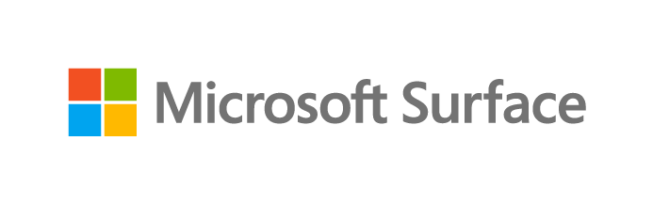
Customer Questionnaire
Modernize with Surface Workshop
Guidance for Presenters

This guide is designed to support preliminary customer conversations in preparation for a Modernize with Surface Workshop. It will help you gather information you need to tailor your workshop and maximize the value of your engagement.

First, set a meeting with the customer and let them know you’ll be asking a series of questions. You’ll be the one filling out this document, so be sure to pre-input any information you already have. You can also add any questions you know will be relevant to your customer or ignore any questions you know won’t be relevant. Ideally, you should keep this meeting to under one hour, so it’s likely that you won’t be able to ask every question during this call. Based on time constraints and your customer’s initial answers, you may want to adjust the order of questions to ensure you cover topics that are most important to them.

The questionnaire starts with basic account information, then leads into context on issues specific to your customer’s business and pain points. It then progresses through a series of questions, grouped by key Modernize with Surface Workshop focus areas. All questions attempt to capture the customer’s current technology environment, pain points and challenges, and goals and opportunities.

Your goal is to arrive at a strong understanding of which focus areas are most important to your customer. The Modernize with Surface Workshop is designed to address the following areas:

- Security
- Manageability
- Productivity and collaboration
- Device lifecycle and total cost of ownership

Once you’ve identified the customer’s challenges and focus areas, you’ll be able to use the modular Modernize with Surface Workshop resources to construct a presentation tailored to their needs.

Contents

Preliminary questions 4
Current business and IT challenges 5
Security 6
Manageability 8
Productivity and collaboration 9
Device lifecycle and total cost of ownership 12
Overall device goals 13

Preliminary questions
Company name | Click or tap here to enter text.
Number of employees | Click or tap here to enter text.
Industry | Click or tap here to enter text.
Active geographies | Click or tap here to enter text.
Microsoft 365 plans and number of seats
Information workers | Click or tap here to enter text.
Frontline workers | Click or tap here to enter text.
Primary device decision maker(s) (name and title) | Click or tap here to enter text.
Contact email(s) | Click or tap here to enter text.
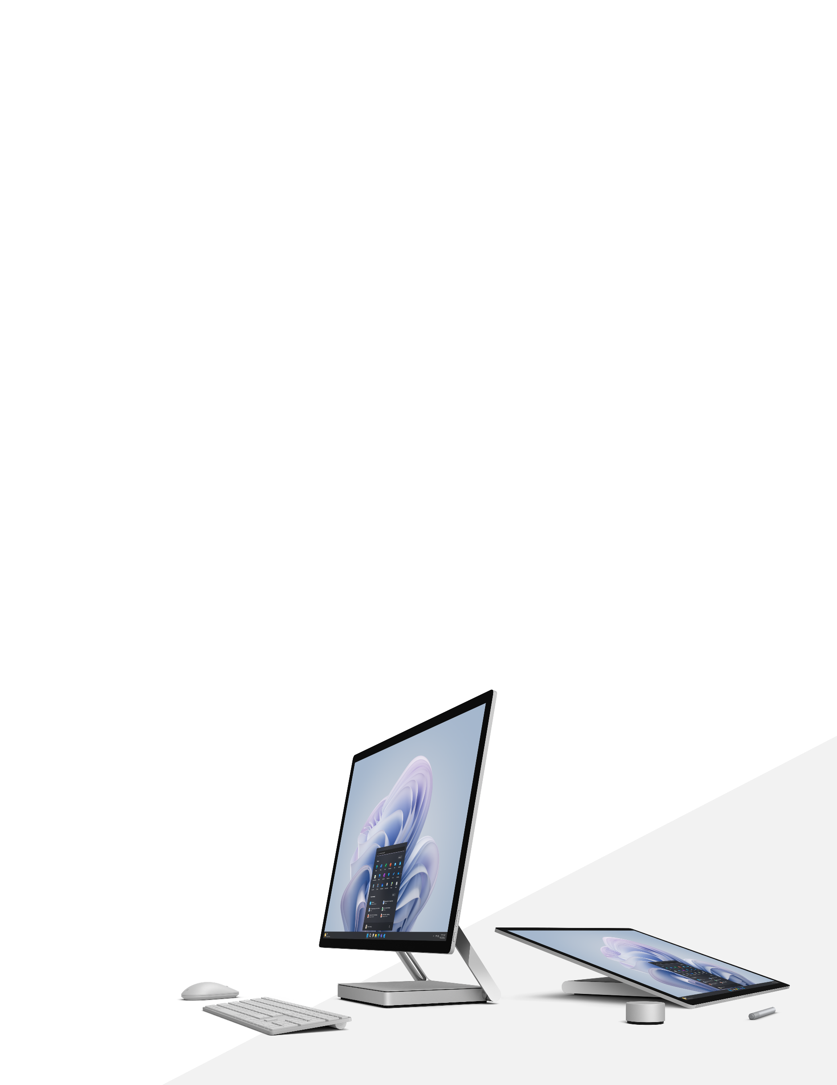

Current business and IT challenges
What industry trends and challenges are especially pronounced in your business?
Click or tap here to enter text.
What are your major business goals for the next one to three years? (e.g., Growth in existing offerings? New lines of business or services? Consolidation? Improving employee retention?)
Click or tap here to enter text.
How do you feel your current technology infrastructure and device strategy prepare you for success or put you at risk moving forward?
Click or tap here to enter text.
How do your employees use devices and different form factors to complete work today?
Click or tap here to enter text.
Do you have specific industry use cases that require modern devices?
Click or tap here to enter text.
What types of devices are employees currently using?
Click or tap here to enter text.
Do employees get to choose their device, or does IT choose for them?
Click or tap here to enter text.
How many different device vendors do you have in your environment?
Click or tap here to enter text.
Do you have loyalty to specific device vendors, or is there an opportunity to consolidate to reduce administration and costs?
Click or tap here to enter text.
What is your typical device refresh cycle? When was the last time you refreshed your devices?
Click or tap here to enter text.
Are there new and additional personas (e.g., Frontline workers) that need modern devices to support industry use cases or business transformation initiatives?
Click or tap here to enter text.
How much budget is allocated towards your next device refresh cycle?
Click or tap here to enter text.
When considering security versus employee experience, which one is more important and to what extent?
Click or tap here to enter text.

Security
What priority does leadership place on security of your company’s IP, data, and employees?
Click or tap here to enter text.
Has leadership allocated budget to improving security?
Click or tap here to enter text.
What is the potential impact of security breaches and data losses to your business?
Click or tap here to enter text.
How real do those threats feel to you?
Click or tap here to enter text.
Have you experienced disruptions based on security issues?
Click or tap here to enter text.
What was the impact on your business? Costs to resolve?
Click or tap here to enter text.
Do you have a Zero-Trust security model? If not, what is the appetite for making this shift?
Click or tap here to enter text.
Do you have a complete understanding of all your endpoints and their vulnerabilities?
Click or tap here to enter text.
How are you managing critical OS, app, and firmware updates to respond to the increase in cyber threats?
Click or tap here to enter text.
Are you taking advantage of Microsoft 365 (Intune, Defender products) to manage and secure your endpoints?
Click or tap here to enter text.
What does an ideal security ecosystem look like to you?
Click or tap here to enter text.
What new security tools has your IT organization been requesting?
Click or tap here to enter text.

Manageability
How do new employees get their devices?
Click or tap here to enter text.
Can you deploy devices to end users remotely without high-touch interventions by IT?
Click or tap here to enter text.
Do employees feel like the onboarding of new devices is a smooth process?
Click or tap here to enter text.
Are your devices optimized for an automated Windows Autopilot experience?
Click or tap here to enter text.
Are you taking advantage of Microsoft 365 (Intune) to manage your devices?
Click or tap here to enter text.
What’s your current OS version?
Click or tap here to enter text.
When are you planning to move to Windows 11?
Click or tap here to enter text.
What’s your current employee experience when it comes to IT managing their devices? Are they satisfied or dissatisfied?
Click or tap here to enter text.
Are you measuring their satisfaction?
Click or tap here to enter text.
How have your goals for device deployment and management changed in the past few years (e.g., since the start of the pandemic)?
Click or tap here to enter text.
What does your ideal device management solution look like?
Click or tap here to enter text.

Productivity and collaboration
How are you using devices to enable hybrid, remote, and frontline work?
Click or tap here to enter text.
Do employees go from being onboarded to being productive as quickly as they would like?
Click or tap here to enter text.
What proportion of your employees’ work is collaborative?
Click or tap here to enter text.
Where are you seeing interruptions to collaboration?
Click or tap here to enter text.
Are these interruptions related to a skills gap, a technology gap, or a shift to a hybrid workplace?
Click or tap here to enter text.
How are their current devices helping or hindering their ability to be collaborative?
Click or tap here to enter text.
What proportion of meetings are now virtual?
Click or tap here to enter text.
What proportion of meetings have a mix of in-person and remote participants?
Click or tap here to enter text.
Are remote participants satisfied or dissatisfied with their virtual meeting experience?
Click or tap here to enter text.
Do meeting participants have digital tools that enable them to whiteboard and ideate freely during virtual meetings?
Click or tap here to enter text.
Are your employees using or planning to use Microsoft Teams for chat, meetings, calls, and document sharing?
Click or tap here to enter text.
Do you use or plan to use Microsoft Teams Rooms for your meeting room solution?
Click or tap here to enter text.
Do you provide employees with modern devices and accessories that enable a great Teams experience?
Click or tap here to enter text.
What other Microsoft 365 apps do your employees lean on the most?
Click or tap here to enter text.
Are you building or executing an adoption strategy to make employees’ usage of Microsoft 365 more effective?
Click or tap here to enter text.
Where are the current gaps in your employees’ daily productivity tools?
Click or tap here to enter text.
Would different device form factors (e.g. 2-in-1s) help boost productivity?
Click or tap here to enter text.

Device lifecycle and total cost of ownership
Does your organization have sustainability goals?
Click or tap here to enter text.
How does IT contribute to those objectives?
Click or tap here to enter text.
Would it help if your device partner had ambitious sustainability goals and could share Eco Profiles that show how much carbon and water goes into designing, manufacturing, delivering, and operating their devices?
Click or tap here to enter text.
Does your typical device last through its expected lifecycle?
Click or tap here to enter text.
Are you getting the value you want out of your devices?
Click or tap here to enter text.
When a device reaches an unexpected end to its lifecycle, what’s the typical cause?
Click or tap here to enter text.
How do you recover and dispose of devices at the end of their lifecycle?
Click or tap here to enter text.
Have your employees expressed any frustration with how their devices suit their specific needs, abilities, or disabilities?
Click or tap here to enter text.

Overall device goals
Ultimately, where do you feel you need the most support in meeting your device goals?
☐ Industry-specific use cases
☐ Security
☐ Device management
☐ Productivity
☐ Collaboration
☐ Sustainability
☐ Accessibility
☐ Device lifecycle
☐ Total cost of ownership

