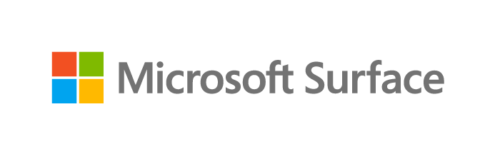

Microsoft Surface Management Portal

Product FAQ

Microsoft Internal & Partner Use Only

Although the information contained in this document is considered public and may be used in discussions with customers, please do not share this document in its entirety.

Last updated: October 22, 2021

This documentation is confidential and proprietary information of Microsoft Corporation, provided for internal and/or partner use, for informational purposes only. Microsoft makes no warranties, either express or implied, in this document. Although the information contained in this document is considered public and may be used in discussions with customers, please do not share this document in its entirety.

© 2021. Microsoft Corporation. All rights reserved.

Contents

Introduction 4
Best of both worlds 5
Delightful post-sale experience 5
Reduce IT cost for the organization 5
Tailormade experience to meet your needs 5
Supports all Surface device form factors 6
Features overview 6
Summary of all features releasing this year 7
What is included in “Monitor” menu? 8
What is included in “All devices” menu? 8
What is included in “Warranty” menu? 9
What is included in “Support” menu? 10
Availability 11
When will Surface Management Portal be available? 12
Is Surface Management Portal available in all countries? 12
Is Surface Management Portal available for GCC, GCC-H and DoD? 12
Is Surface Management Portal available for Education customers? 12
When will this be announced publicly? 12
Is Intune same as Microsoft Endpoint Manager (MEM) 12
Why is Surface Management Portal in Microsoft Endpoint Manager (MEM)? 12
Will SMP be available through SCCM (System Center Configuration Manager) 12
Is SMP available to partners? 12
System requirements 12
What are the system requirements for Microsoft Surface Management Portal? 13
If customers meet all the above requirements, how can they enable SMP? 13
Where can I find Surface Management Portal in Microsoft Endpoint Manager? 13
Does installation require a trained technician? 13
What user-type of MEM can access SMP? 13
Which Surface devices are supported? 13
Customer already have Surface devices in MEM, should they re-enrol devices? 13
Better M365 experience for Surface 13
How does SMP align with our broader commercial story? 14
Who is the target audience for Surface Management Portal? 14
What if the customer does not have any Surface devices deployed in their environment? 14
Is Surface Management Portal available in M365 Admin centre? 14
How is Microsoft Endpoint Manager enhanced for Surface? 14
Building for the future of workplace 14
How is Surface Management Portal built to address the needs of future of workplace 15
Are there more features that will be coming in SMP? 15
Are there more features that will be coming in SMP? 15
Is Surface Management Portal accessible? 15
How can customers get an update to SMP when new features are enabled in the future? 15
Can you place request for bulk device replacement through Surface Management Portal? 15
Troubleshooting made easier 15
Can customers share device date with Microsoft sales or support? 16
Is SMP the only Microsoft Portal that gives consolidated device warranty overview? 16
How can sales team try this in their test tenants? 16
Can customer filter and customize the data table according to their needs? 16
Can customer find out how many devices are going out of warranty? 16
Can customers export data available in Microsoft Endpoint Manager? 16
Learn more 16

Introduction
Microsoft Surface Management Portal was built for the new modern hybrid workplace to adapt to the changing needs of organizations and employees. Many organizations have switched to a more flexible work setup, and we built an experience to meet the needs of a new changing world. Surface Management Portal makes managing all Surface devices easier than ever before – be it corporate owned, bring your own device (BYOD) or choose your own device (CYOD), managing Surface devices has never been this easier

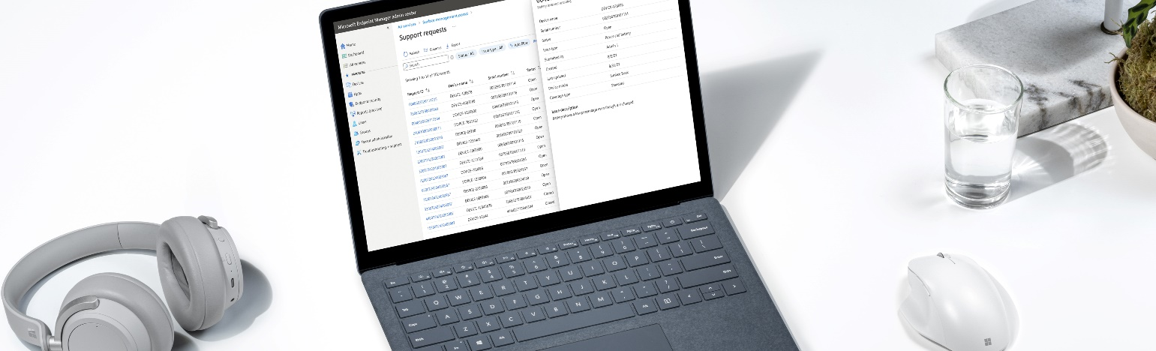

Best of both worlds
In 2017, Surface partnered with Intune to create a seamless deployment experience through Autopilot and then in 2019, we did it yet again with advanced UEFI management with DFCI (Device Firmware Configuration Interface). Now we have taken a step further to enhance Surface management experience through Microsoft Surface Management Portal. We are bringing new set of capabilities to Microsoft Endpoint Manager to make it easier for customers to manage all Surface devices at different stages of device life cycle.

Delightful post-sale experience
Microsoft Surface Management Portal is a centralized solution for IT admins to self-serve, manage and monitor all Microsoft Surface devices at scale in Microsoft Endpoint Manager. After research, we evaluated many options and created an experience that enables you to self-serve in a seamless fashion. Surface and Microsoft Endpoint Manager comes together to create a delightful post-sale experience for our customers.

Reduce IT cost for the organization
With one quick view, you can now access important insights such as low device storage, non-compliant devices, inactive devices, unencrypted devices, and information of all Surface devices that needs immediate action. What would take customers days, now only takes seconds. Managing warranty and support requests is as simple as a click of a button. We have created one simplistic view to highlight all important device status while also enabling you to dig deeper for troubleshooting

Tailormade experience to meet your needs
We reimaged an experience that would meet customer needs in managing lifecycle of their devices in a seamless way. With the news feature in Surface Management Portal, customers can now stay up to date with the latest and the greatest updates from Surface curated just for IT audience in the enterprise space.

Supports all Surface device form factors
Surface Management Portal is available for all supported Surface devices including traditional form factors such as Surface Laptop, Surface Book, Surface Go, Surface Pro, Surface Go and Surface Laptop Go along with ARM based Pro X, Surface Hub with Teams OS, and Surface Duo with Android OS.

Features overview

Summary of all features releasing this year

Feature | Customer Value​ | “The Why” | Details
Device overview | Reduced IT cost for the organization | Customers need a way to view all device insights in one location | - Overview of all Surface devices  - Surface device asset management  - Warranty status  - Track status of newly created support requests  - Latest news from Surface engineering to IT admins
Warranty overview | Delightful post-sale experience | Customers:  “I have no idea if my devices are in warranty”  “I did not know I could add protection plans” | - Warranty status of all devices:  - In-warranty  - Eligible for adding protection plans  - Out-of-warranty  - Going out of warranty soon  - Warranty details  - Standard  - Accidental Damage Protection  - Extended Service Plan
Support  overview | Reduced IT cost for the organization | It is Hard for customers to manage emails for each service order and current support process is long and repetitive | - Status of newly created support requests  - Filtered view to gain insights into latest updates on created support requests  - Important resources for help
Device summary | Delightful post-sale experience | Monitor health and device insights at a deeper level | Detailed device information summary view  - System (OS version, OS type, Model)  - User (Device owner details)  - Status (Enrollment, Active, Last active)  - Health (Update history, Restart, Bit locker status, TPM, Total free space)
Surface news | Self-serve | Keep the IT admins informed about the latest engineering updates for Surface | Dynamically query the latest IT pro blog and show updates on all things new in the enterprise space for our IT audience

What is included in “Monitor” menu?
- Customers now have one unified location to view list of all Surface devices in the organization. Surface Management Portal will be available within All services under the name “Surface management portal”
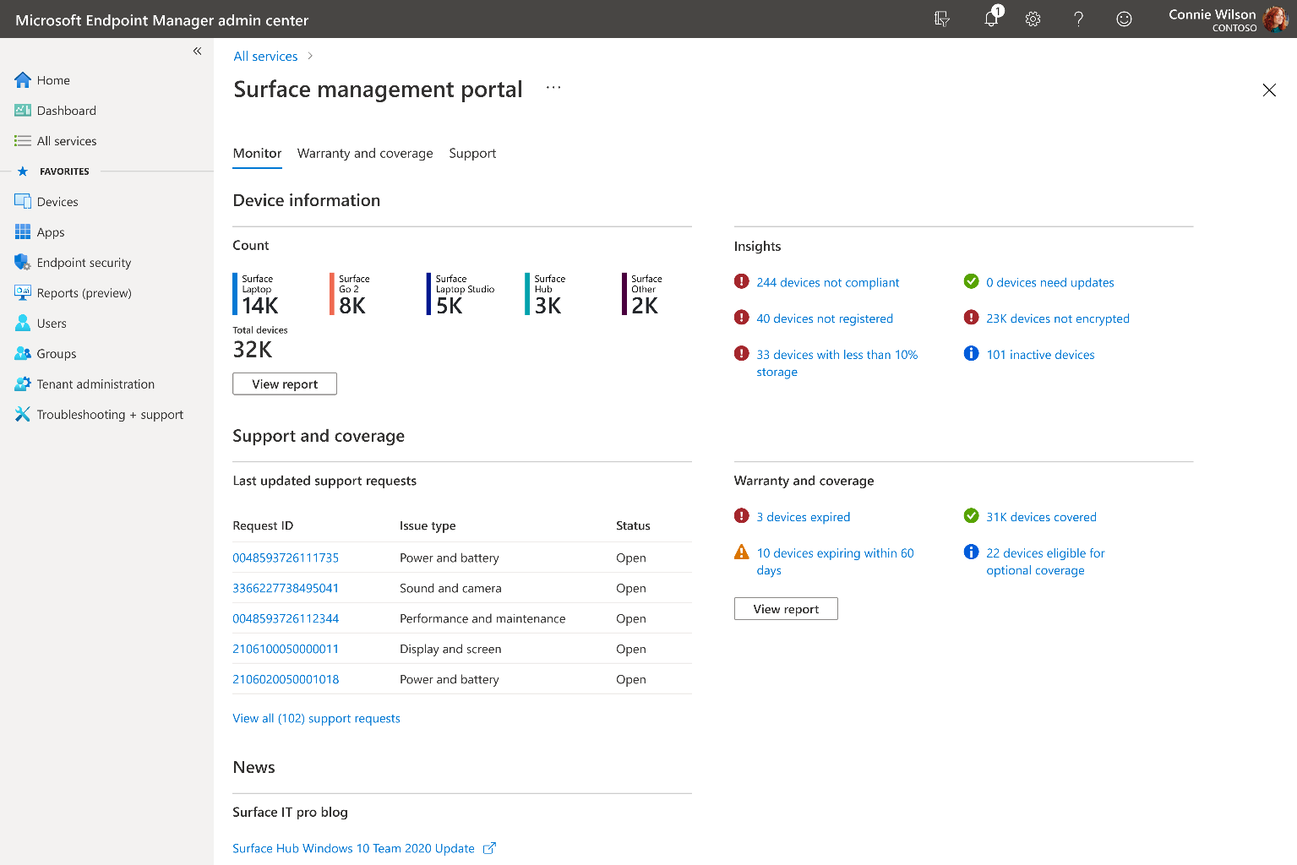

All Surface device section also allows customers to view detailed health view of all their Surface devices through customizable filtering options
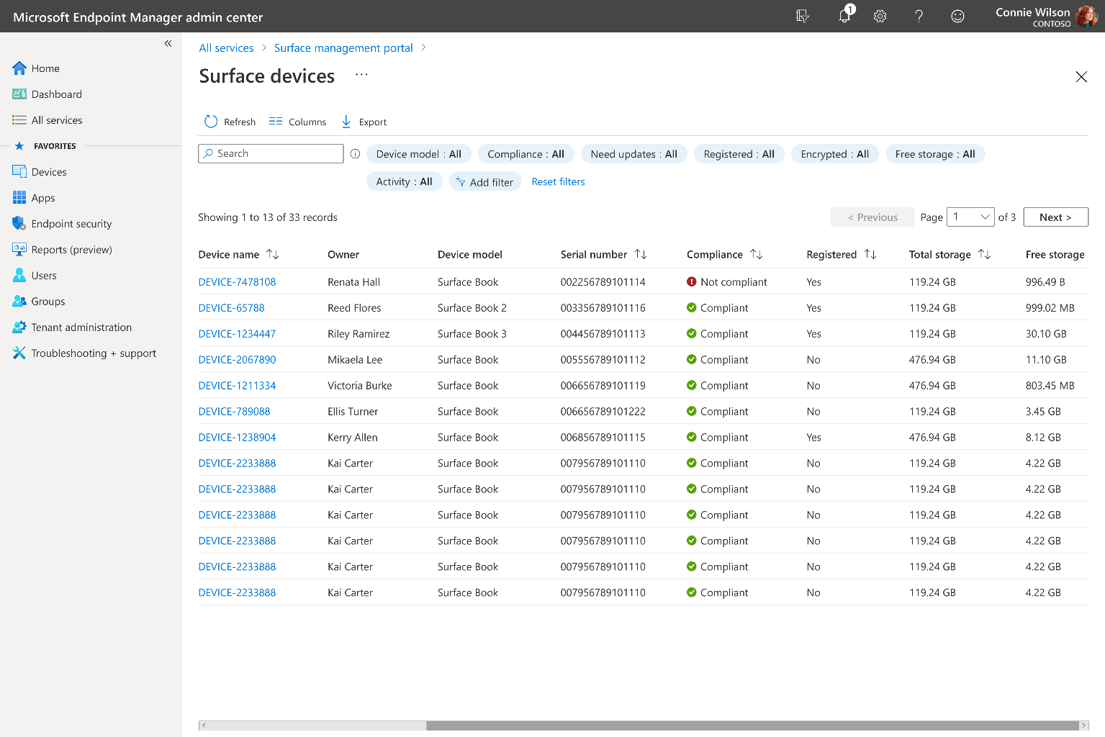

What is included in “Warranty” menu?
What would take customers hours to query warranty information of all surface devices in the organization, now only takes a few minutes with Surface Management Portal. Customers can now view warranty data of all Surface devices in one simplified view. This can also aid in planning for device refresh and easier life cycle management of devices
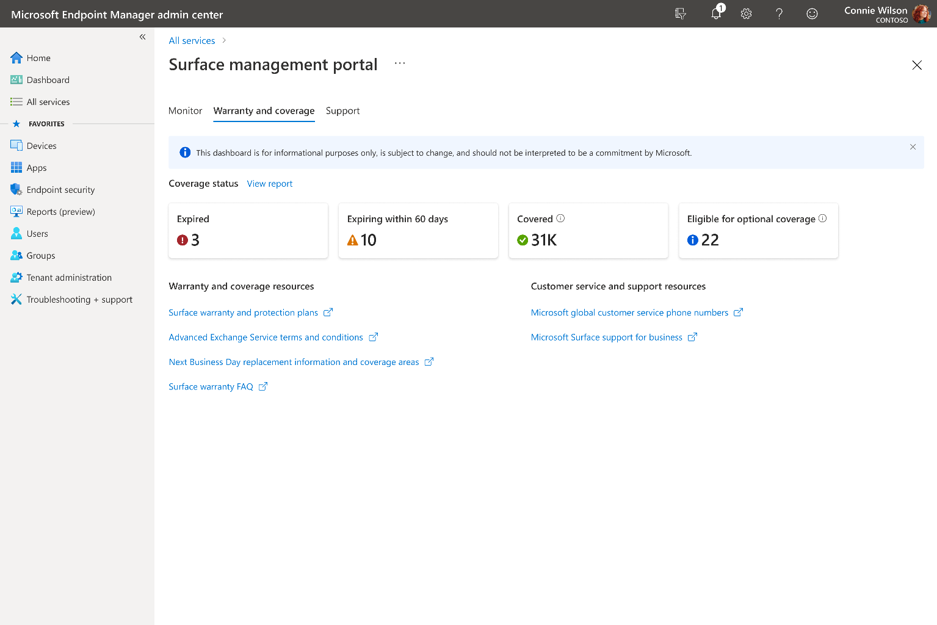

What is included in “Support” menu?
We consolidated various sources and built an experience that lets customers monitor all Surface support requests in one location enabling them to self-serve. Purpose-built to replace tracking multiple emails with a simplistic view of latest updates to support requests initiated with Microsoft

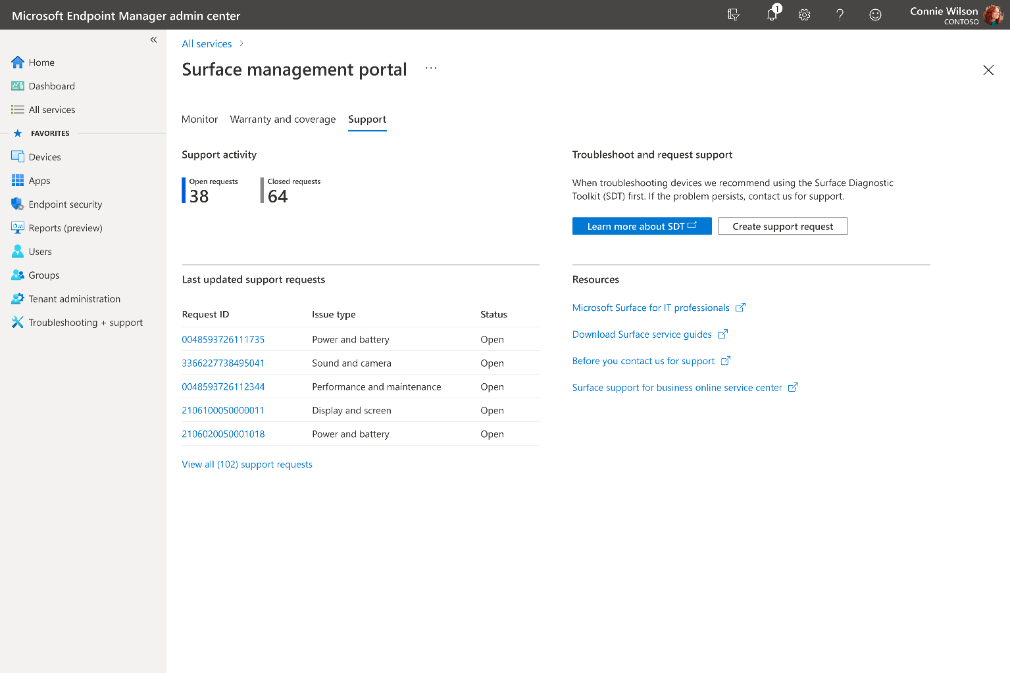

Availability

When will Surface Management Portal be available?
- Surface Management Portal will be available in USA on October 28th, 2021 and will be rolled out to all other countries incrementally.

Is Surface Management Portal available in all countries?
- SMP will be available in USA on October 28th and will be available internationally across all countries by the end of the year 2021

Is Surface Management Portal available for GCC, GCC-H and DoD?
- SMP will be enabled across new industry segments such as GCC as part of post launch (After Oct 2021)

Is Surface Management Portal available for Education customers?
- SMP is available for customers who use Microsoft Endpoint Manager and have enrolled Surface devices through Intune

When will this be announced publicly?
- Public announcement is scheduled on September 22nd
- Announcement will be in the form of Surface IT Pro Blog Post (Along with Surface device launch)

Is Intune same as Microsoft Endpoint Manager (MEM)
- Intune is a cloud-based service that focuses on mobile device management whereas MEM is a unified platform that includes both configuration manager and Microsoft Intune

Why is Surface Management Portal in Microsoft Endpoint Manager (MEM)?
- We wanted to create a one stop solution to managing devices. Customers already use Microsoft Endpoint Manager to manage their devices, so we wanted to meet customers where they are.

Will SMP be available through SCCM (System Center Configuration Manager)
- SMP will be available to Intune as well as hybrid- cloud managed devices. If devices are enrolled through traditional SCCM with no cloud component attached, then SMP will not be available to such customers.

Is SMP available to partners?
- If partners are the ones who manage customer’s devices in MEM, they can access to SMP. However, SMP is not available as a separate portal for partners.

System requirements

What are the system requirements for Microsoft Surface Management Portal?
- Customer should have access to Microsoft Endpoint Manager
- Devices enrolled through Intune
- Surface devices in the estate

If customers meet all the above requirements, how can they enable SMP?
- We wanted to meet customers where they are. If the above requirements are met, SMP will be available automatically

Where can I find Surface Management Portal in Microsoft Endpoint Manager?
- Surface Management Portal will be available within All services menu under the name “Surface management portal”

Does installation require a trained technician?
- Microsoft Endpoint Manager is an easy-to-use device management solution. Any user who uses MEM can use SMP with no additional learning required

What user-type of MEM can access SMP?
- Each Azure Active Directory role in MEM is created to meet different device management needs. The first launch of SMP in 2021 will have features enabled for most of the roles. As more features

Which Surface devices are supported?
- All supported Surface devices including traditional form factors such as Surface Laptop, Surface Book, Surface Go, Surface Pro, Surface Go and Surface Laptop Go supports Surface Management Portal along with ARM based Pro X, Surface Hub with Teams OS, and Surface Duo with Android OS.
- In short, all supported Surface devices can take advantage of Surface Management Portal

Customer already have Surface devices in MEM, should they re-enrol devices?
- All Surface management portal features will be available for already enrolled as well as newly enrolled Surface devices in Intune

Better M365 experience for Surface

How does SMP align with our broader commercial story?
- In 2017, we enabled Autopilot for Surface, then continued to build advanced UEFI policy settings through DFCI in 2019. Now we took a step further to create a delightful post-sale experience as part of broader “Surface is better with M365” story

Who is the target audience for Surface Management Portal?
- IT admins of organization, organization’s support leads, and device purchase decision makers can find advantage in using Surface Management Portal?

What if the customer does not have any Surface devices deployed in their environment?
- If Surface devices are not enrolled in Microsoft Endpoint manager, then SMP will show the following message: “No Surface devices found in your organization”

Is Surface Management Portal available in M365 Admin centre?
- No. Surface Management Portal is available only in Microsoft Endpoint Manager since Microsoft Endpoint manager is the ultimate unified solution to managing all devices at scale

How is Microsoft Endpoint Manager enhanced for Surface?
- Microsoft Endpoint Manager and Microsoft Surface teams worked together to bring a more seamless experience to our customers
- If customers use Surface, then they can leverage additional capabilities that is built into Microsoft Endpoint Manager through Surface Management Portal
- If Surface devices are not enrolled in Microsoft Endpoint manager, then SMP will show the following message: “No Surface devices found in your organization”

Building for the future of workplace

How is Surface Management Portal built to address the needs of future of workplace
- We envision that the world will be more hybrid and flexible than ever before. This means, IT admins or help desk may not be in the same place as the customer having issue with the device. With Surface Management Portal, we are setting baseline foundation for what the future of managing devices may look like. Even though we are only starting with simple yet much needed features like warranty and support request management in one place, this is only a starting point and more advanced capabilities will be unlocked in the future iteration.

Are there more features that will be coming in SMP?
- Yes, Surface has made a huge investment to create a delightful post-sale experience for our customers. Major feature releases will follow Spring and Holiday Surface launch with incremental updates added throughout the year

Are there more features that will be coming in SMP?
- Yes, Surface has made a huge investment to create a delightful post-sale experience for our customers. Major feature releases will follow Spring and Holiday Surface launch with incremental updates added throughout the year

Is Surface Management Portal accessible?
- Yes! Making Surface Management Portal inclusive and usable by everyone was one of our primary goals. While the color scheme and formatting are easy on the eyes for everyone, it also follows Microsoft design guidelines for accessibility to make it more inclusive.

How can customers get an update to SMP when new features are enabled in the future?
- Updates will be automatically available based on region.

Can you place request for bulk device replacement through Surface Management Portal?
- No. The first iteration of Surface management portal does not allow bulk device replacement. However, there is a plan to bring this feature in the future to make device life cycle management easier

Troubleshooting made easier

Can customers share device date with Microsoft sales or support?
- Support tickets created by the customers are handled by Microsoft support team.
- Customers have the option to export data from Surface Management Portal and share with their respective sales lead if necessary

Is SMP the only Microsoft Portal that gives consolidated device warranty overview?
- Yes. Warranty information of Surface devices can be found at scale only in SMP.

How can sales team try this in their test tenants?
- Surface Management Portal can be found under “Devices” menu of Microsoft Endpoint Manager starting Oct 28th. Anyone with Intune demo tenant can try this without additional steps

Can customer filter and customize the data table according to their needs?
- Extensive research was done to show the most vital details first. However, we have enabled a lot of customization options through filtering
- 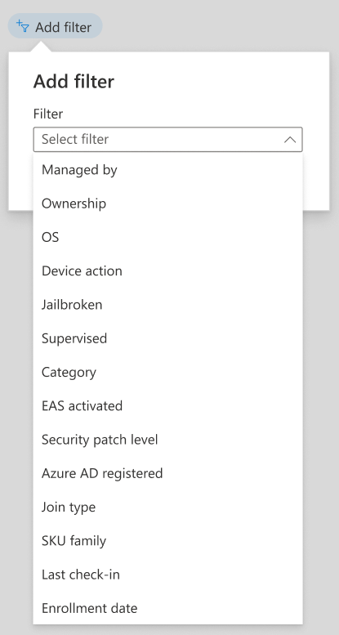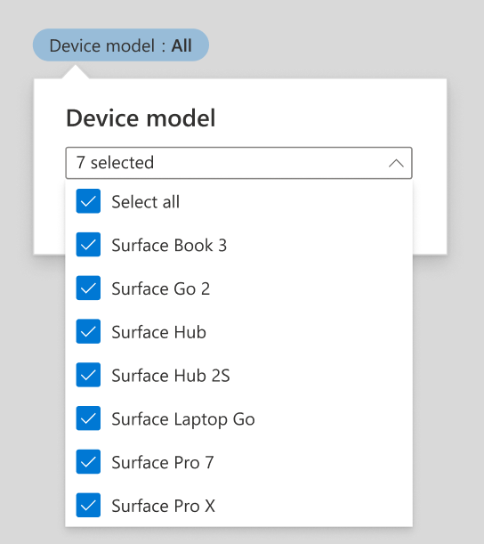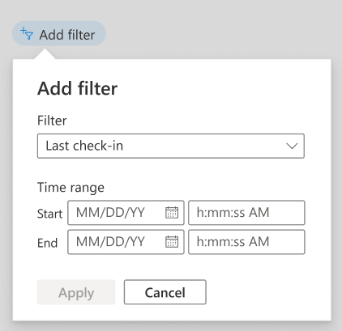

Can customer find out how many devices are going out of warranty?
- Yes, reviewing warranty data is made super easy by Surface management portal. Along with quick and effortless way to view number of devices going out of warranty soon, customers can also view detailed warranty data and filter them according to their desired queries (Ex: Shows Surface devices going out of warranty in next 60 days)

Can customers export data available in Microsoft Endpoint Manager?
Yes, exporting data is made simple in SMP with just a click of an export button.

Learn more
- IT Pro (sharepoint.com)

